Requirements/Design Specification

**Missing Competitor El coqui Landfill**

**GH 514 – CR 13930**

Revision History

|  |  |  |  |
| --- | --- | --- | --- |
| **Date** | **Revision** | **Description** | **Author** |
| 4/29/2015 | 1.0 | Initial Version with Requirements | Roger Behm |
|  |  |  |  |
|  |  |  |  |
|  |  |  |  |
|  |  |  |  |

The information furnished herein by Republic Services Inc. is proprietary and confidential to Republic Services Inc. personnel and is not to be duplicated, published, or disclosed to any third party in whole or in part without permission from Republic Services, Inc.

© Copyright 2012, Republic Services Inc. - All rights reserved.

Table of contents

1 Business Requirements/Owner – Brittany Smith 6

2 Assumptions 6

3 Design 6

4 InfoPro/TIBCO/BI Impacts 6

5 Report Changes 7

6 Appendix 7

# Business Requirements/Owner – Brittany Smith

Area19 Division 4812 and 4810 need the following Competitor

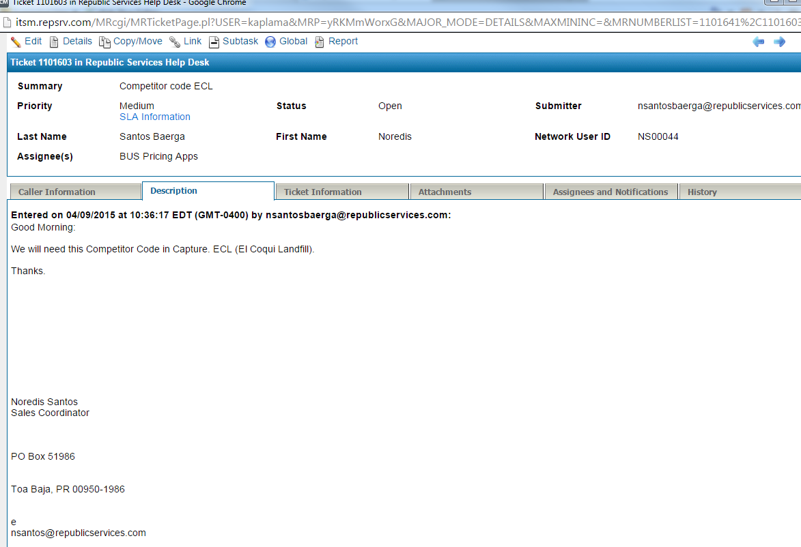

# Assumptions

NA

# Design

The value El Coqui Landfill - ECL needs to be added to the menu items for the configurable attribute competitor In the Entry Manager.

The div_competitor_adj table needs two rows for divisions 4810 and 4812 containing ECL El Coqui Landfill.

CMCs need to be updated appropriately.

# InfoPro/TIBCO/BI Impacts

No new variable should be needed and no existing variables should be repurposed for any of the above changes.

# Report Changes

NA

# Appendix